**ASSIGNMENT: 1**

**CREATE DATABASE:**



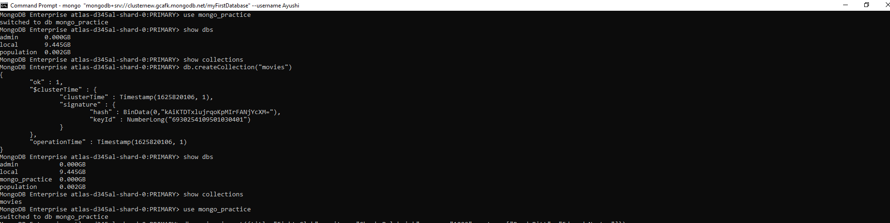

MongoDB Enterprise atlas-d345al-shard-0:PRIMARY> use mongo_practice

switched to db mongo_practice

MongoDB Enterprise atlas-d345al-shard-0:PRIMARY> show dbs

admin 0.000GB

local 9.445GB

population 0.002GB

MongoDB Enterprise atlas-d345al-shard-0:PRIMARY> show collections

MongoDB Enterprise atlas-d345al-shard-0:PRIMARY> db.createCollection("movies")

{

"ok" : 1,

"$clusterTime" : {

"clusterTime" : Timestamp(1625820106, 1),

"signature" : {

"hash" : BinData(0,"kAiKTDTxlujrqoKpMIrFANjYcXM="),

"keyId" : NumberLong("6930254109501030401")

}

},

"operationTime" : Timestamp(1625820106, 1)

}

MongoDB Enterprise atlas-d345al-shard-0:PRIMARY> show dbs

admin 0.000GB

local 9.445GB

mongo_practice 0.000GB

population 0.002GB

MongoDB Enterprise atlas-d345al-shard-0:PRIMARY> show collections

movies

MongoDB Enterprise atlas-d345al-shard-0:PRIMARY> use mongo_practice

switched to db mongo_practice

**OUTPUT:**

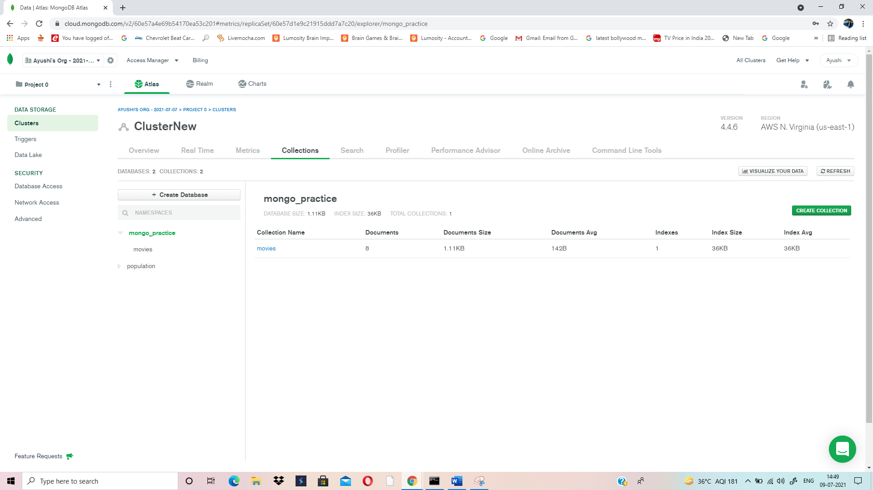

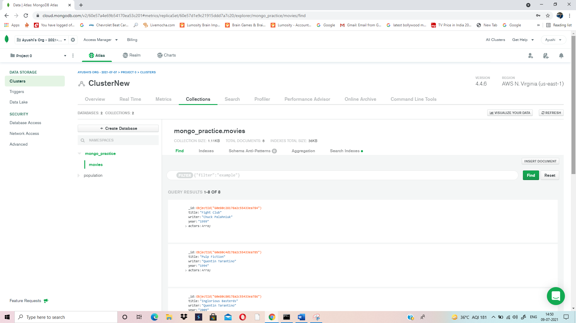

**INSERT DOCUMENT:**

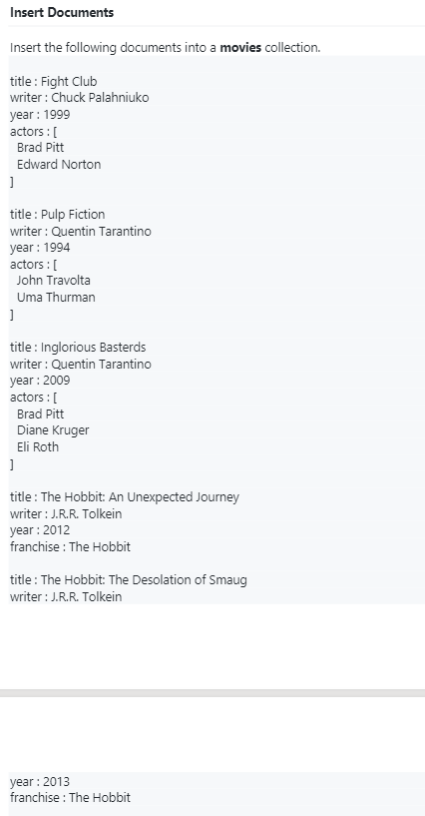

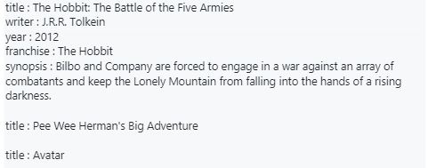

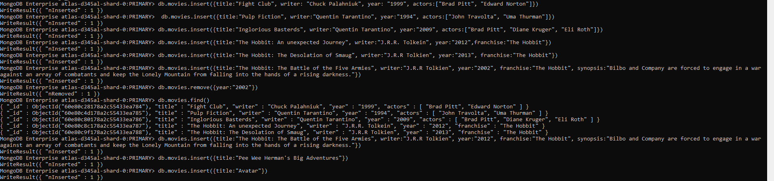

MongoDB Enterprise atlas-d345al-shard-0:PRIMARY> db.movies.insert({title:"Fight Club", writer: "Chuck Palahniuk", year: "1999", actors:["Brad Pitt", "Edward Norton"]})

WriteResult({ "nInserted" : 1 })

MongoDB Enterprise atlas-d345al-shard-0:PRIMARY> db.movies.insert({title:"Pulp Fiction", writer:"Quentin Tarantino", year:"1994", actors:["John Travolta", "Uma Thurman"]})

WriteResult({ "nInserted" : 1 })

MongoDB Enterprise atlas-d345al-shard-0:PRIMARY> db.movies.insert({title:"Inglorious Basterds", writer:"Quentin Tarantino", year:"2009", actors:["Brad Pitt", "Diane Kruger", "Eli Roth"]})

WriteResult({ "nInserted" : 1 })

MongoDB Enterprise atlas-d345al-shard-0:PRIMARY> db.movies.insert({title:"The Hobbit: An unexpected Journey", writer:"J.R.R. Tolkein", year:"2012",franchise:"The Hobbit"})

WriteResult({ "nInserted" : 1 })

MongoDB Enterprise atlas-d345al-shard-0:PRIMARY> db.movies.insert({title:"The Hobbit: The Desolation of Smaug", writer:"J.R.R Tolkien", year:"2013", franchise:"The Hobbit"})

WriteResult({ "nInserted" : 1 })

MongoDB Enterprise atlas-d345al-shard-0:PRIMARY> db.movies.insert({title:"The Hobbit: The Battle of the Five Armies", writer:"J.R.R Tolkien", year:"2002", franchise:"The Hobbit", synopsis:"Bilbo and Company are forced to engage in a war against an array of combatants and keep the Lonely Mountain from falling into the hands of a rising darkness."})

WriteResult({ "nInserted" : 1 })

MongoDB Enterprise atlas-d345al-shard-0:PRIMARY> db.movies.remove({year:"2002"})

WriteResult({ "nRemoved" : 1 })

MongoDB Enterprise atlas-d345al-shard-0:PRIMARY> db.movies.find()

{ "_id" : ObjectId("60e80c28178a2c55433ea784"), "title" : "Fight Club", "writer" : "Chuck Palahniuk", "year" : "1999", "actors" : [ "Brad Pitt", "Edward Norton" ] }

{ "_id" : ObjectId("60e80c4d178a2c55433ea785"), "title" : "Pulp Fiction", "writer" : "Quentin Tarantino", "year" : "1994", "actors" : [ "John Travolta", "Uma Thurman" ] }

{ "_id" : ObjectId("60e80c80178a2c55433ea786"), "title" : "Inglorious Basterds", "writer" : "Quentin Tarantino", "year" : "2009", "actors" : [ "Brad Pitt", "Diane Kruger", "Eli Roth" ] }

{ "_id" : ObjectId("60e80c8c178a2c55433ea787"), "title" : "The Hobbit: An unexpected Journey", "writer" : "J.R.R. Tolkein", "year" : "2012", "franchise" : "The Hobbit" }

{ "_id" : ObjectId("60e80c9f178a2c55433ea788"), "title" : "The Hobbit: The Desolation of Smaug", "writer" : "J.R.R Tolkien", "year" : "2013", "franchise" : "The Hobbit" }

MongoDB Enterprise atlas-d345al-shard-0:PRIMARY> db.movies.insert({title:"The Hobbit: The Battle of the Five Armies", writer:"J.R.R Tolkien", year:"2012", franchise:"The Hobbit", synopsis:"Bilbo and Company are forced to engage in a war against an array of combatants and keep the Lonely Mountain from falling into the hands of a rising darkness."})

WriteResult({ "nInserted" : 1 })

MongoDB Enterprise atlas-d345al-shard-0:PRIMARY> db.movies.insert({title:"Pee Wee Herman's Big Adventures"})

WriteResult({ "nInserted" : 1 })

MongoDB Enterprise atlas-d345al-shard-0:PRIMARY> db.movies.insert({title:"Avatar"})

WriteResult({ "nInserted" : 1 })

**OUTPUT:**

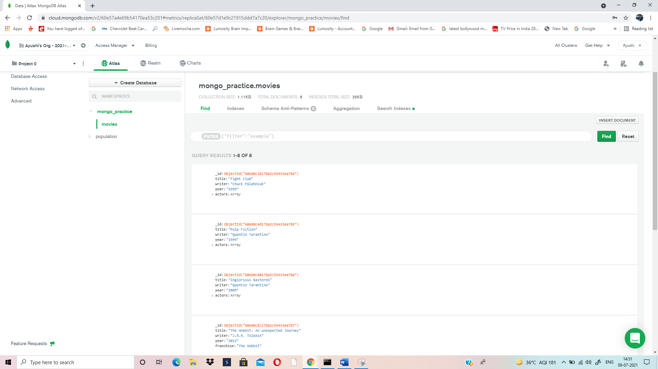

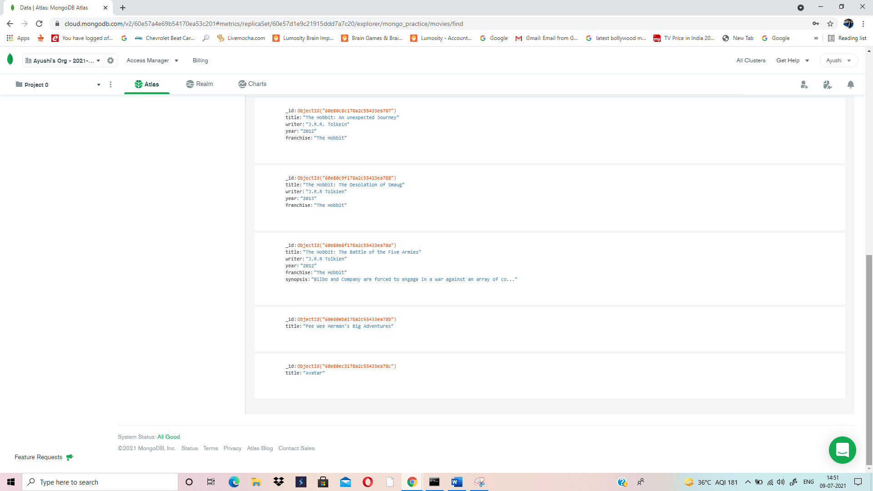

**QUERY/ FIND DOCUMENTS:**

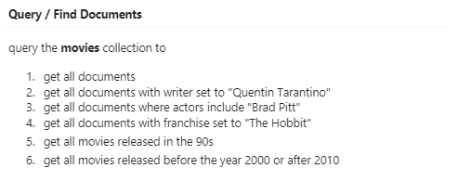

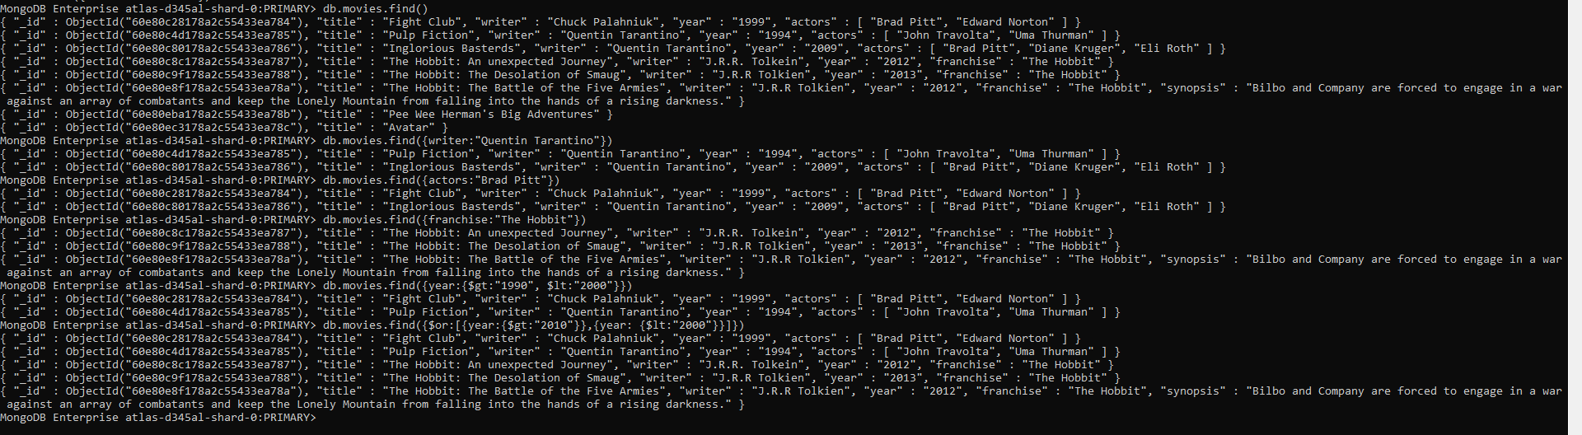

MongoDB Enterprise atlas-d345al-shard-0:PRIMARY> db.movies.find()

{ "_id" : ObjectId("60e80c28178a2c55433ea784"), "title" : "Fight Club", "writer" : "Chuck Palahniuk", "year" : "1999", "actors" : [ "Brad Pitt", "Edward Norton" ] }

{ "_id" : ObjectId("60e80c4d178a2c55433ea785"), "title" : "Pulp Fiction", "writer" : "Quentin Tarantino", "year" : "1994", "actors" : [ "John Travolta", "Uma Thurman" ] }

{ "_id" : ObjectId("60e80c80178a2c55433ea786"), "title" : "Inglorious Basterds", "writer" : "Quentin Tarantino", "year" : "2009", "actors" : [ "Brad Pitt", "Diane Kruger", "Eli Roth" ] }

{ "_id" : ObjectId("60e80c8c178a2c55433ea787"), "title" : "The Hobbit: An unexpected Journey", "writer" : "J.R.R. Tolkein", "year" : "2012", "franchise" : "The Hobbit" }

{ "_id" : ObjectId("60e80c9f178a2c55433ea788"), "title" : "The Hobbit: The Desolation of Smaug", "writer" : "J.R.R Tolkien", "year" : "2013", "franchise" : "The Hobbit" }

{ "_id" : ObjectId("60e80e8f178a2c55433ea78a"), "title" : "The Hobbit: The Battle of the Five Armies", "writer" : "J.R.R Tolkien", "year" : "2012", "franchise" : "The Hobbit", "synopsis" : "Bilbo and Company are forced to engage in a war against an array of combatants and keep the Lonely Mountain from falling into the hands of a rising darkness." }

{ "_id" : ObjectId("60e80eba178a2c55433ea78b"), "title" : "Pee Wee Herman's Big Adventures" }

{ "_id" : ObjectId("60e80ec3178a2c55433ea78c"), "title" : "Avatar" }

MongoDB Enterprise atlas-d345al-shard-0:PRIMARY> db.movies.find({writer:"Quentin Tarantino"})

{ "_id" : ObjectId("60e80c4d178a2c55433ea785"), "title" : "Pulp Fiction", "writer" : "Quentin Tarantino", "year" : "1994", "actors" : [ "John Travolta", "Uma Thurman" ] }

{ "_id" : ObjectId("60e80c80178a2c55433ea786"), "title" : "Inglorious Basterds", "writer" : "Quentin Tarantino", "year" : "2009", "actors" : [ "Brad Pitt", "Diane Kruger", "Eli Roth" ] }

MongoDB Enterprise atlas-d345al-shard-0:PRIMARY> db.movies.find({actors:"Brad Pitt"})

{ "_id" : ObjectId("60e80c28178a2c55433ea784"), "title" : "Fight Club", "writer" : "Chuck Palahniuk", "year" : "1999", "actors" : [ "Brad Pitt", "Edward Norton" ] }

{ "_id" : ObjectId("60e80c80178a2c55433ea786"), "title" : "Inglorious Basterds", "writer" : "Quentin Tarantino", "year" : "2009", "actors" : [ "Brad Pitt", "Diane Kruger", "Eli Roth" ] }

MongoDB Enterprise atlas-d345al-shard-0:PRIMARY> db.movies.find({franchise:"The Hobbit"})

{ "_id" : ObjectId("60e80c8c178a2c55433ea787"), "title" : "The Hobbit: An unexpected Journey", "writer" : "J.R.R. Tolkein", "year" : "2012", "franchise" : "The Hobbit" }

{ "_id" : ObjectId("60e80c9f178a2c55433ea788"), "title" : "The Hobbit: The Desolation of Smaug", "writer" : "J.R.R Tolkien", "year" : "2013", "franchise" : "The Hobbit" }

{ "_id" : ObjectId("60e80e8f178a2c55433ea78a"), "title" : "The Hobbit: The Battle of the Five Armies", "writer" : "J.R.R Tolkien", "year" : "2012", "franchise" : "The Hobbit", "synopsis" : "Bilbo and Company are forced to engage in a war against an array of combatants and keep the Lonely Mountain from falling into the hands of a rising darkness." }

MongoDB Enterprise atlas-d345al-shard-0:PRIMARY> db.movies.find({year:{$gt:"1990", $lt:"2000"}})

{ "_id" : ObjectId("60e80c28178a2c55433ea784"), "title" : "Fight Club", "writer" : "Chuck Palahniuk", "year" : "1999", "actors" : [ "Brad Pitt", "Edward Norton" ] }

{ "_id" : ObjectId("60e80c4d178a2c55433ea785"), "title" : "Pulp Fiction", "writer" : "Quentin Tarantino", "year" : "1994", "actors" : [ "John Travolta", "Uma Thurman" ] }

MongoDB Enterprise atlas-d345al-shard-0:PRIMARY> db.movies.find({$or:[{year:{$gt:"2010"}},{year: {$lt:"2000"}}]})

{ "_id" : ObjectId("60e80c28178a2c55433ea784"), "title" : "Fight Club", "writer" : "Chuck Palahniuk", "year" : "1999", "actors" : [ "Brad Pitt", "Edward Norton" ] }

{ "_id" : ObjectId("60e80c4d178a2c55433ea785"), "title" : "Pulp Fiction", "writer" : "Quentin Tarantino", "year" : "1994", "actors" : [ "John Travolta", "Uma Thurman" ] }

{ "_id" : ObjectId("60e80c8c178a2c55433ea787"), "title" : "The Hobbit: An unexpected Journey", "writer" : "J.R.R. Tolkein", "year" : "2012", "franchise" : "The Hobbit" }

{ "_id" : ObjectId("60e80c9f178a2c55433ea788"), "title" : "The Hobbit: The Desolation of Smaug", "writer" : "J.R.R Tolkien", "year" : "2013", "franchise" : "The Hobbit" }

{ "_id" : ObjectId("60e80e8f178a2c55433ea78a"), "title" : "The Hobbit: The Battle of the Five Armies", "writer" : "J.R.R Tolkien", "year" : "2012", "franchise" : "The Hobbit", "synopsis" : "Bilbo and Company are forced to engage in a war against an array of combatants and keep the Lonely Mountain from falling into the hands of a rising darkness." }

MongoDB Enterprise atlas-d345al-shard-0:PRIMARY>

**UPDATE DOCUMENTS:**

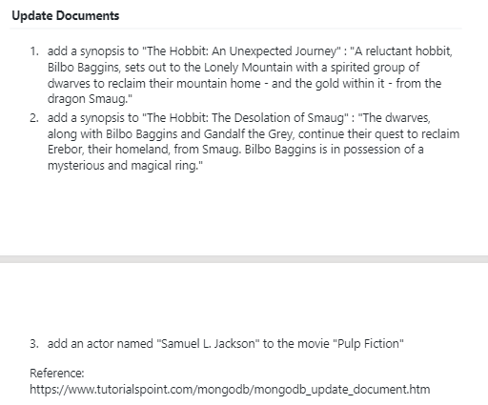



MongoDB Enterprise atlas-d345al-shard-0:PRIMARY> db.movies.update({_id:ObjectId("60e80c8c178a2c55433ea787")}, {$set:{synopsis:"A reluctant hobbit, Bilbo Baggins, sets out to the Lonely Mountain with a spirited group of dwarves to reclaim their mountain home - and the gold within it - from the dragon Smaug."}})

WriteResult({ "nMatched" : 1, "nUpserted" : 0, "nModified" : 1 })

MongoDB Enterprise atlas-d345al-shard-0:PRIMARY> db.movies.update({_id:ObjectId("60e80c9f178a2c55433ea788")}, {$set:{synopsis:"The dwarves, along with Bilbo Baggins and Gandalf the Grey, continue their quest to reclaim Erebor, their homeland, from Smaug. Bilbo Baggins is in possession of a mysterious and magical ring."}})

WriteResult({ "nMatched" : 1, "nUpserted" : 0, "nModified" : 1 })

MongoDB Enterprise atlas-d345al-shard-0:PRIMARY> db.movies.update({_id:ObjectId("60e80c4d178a2c55433ea785")}, {$push:{actors:"Samuel L. Jackson"}})

WriteResult({ "nMatched" : 1, "nUpserted" : 0, "nModified" : 1 })

MongoDB Enterprise atlas-d345al-shard-0:PRIMARY>

**OUTPUT:**

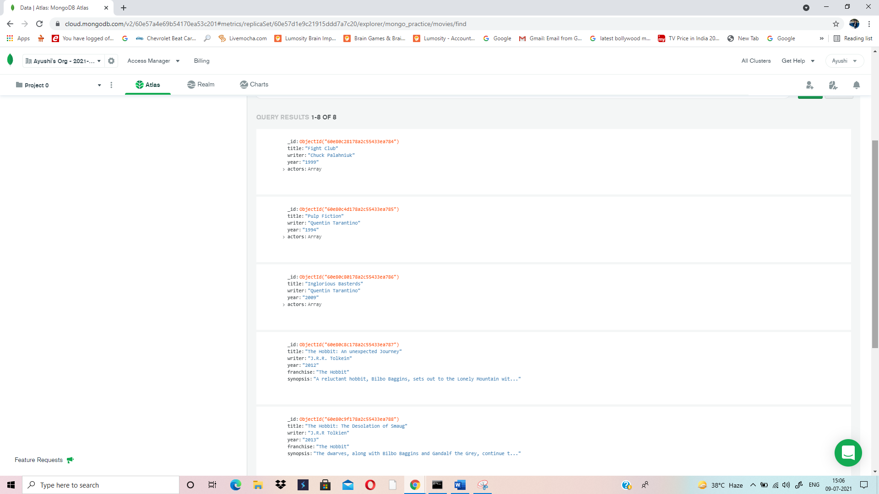

**TEXT SEARCH:**

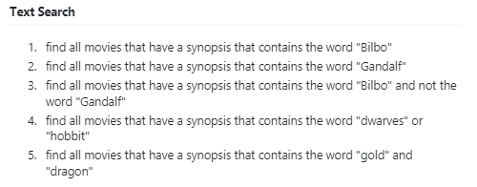

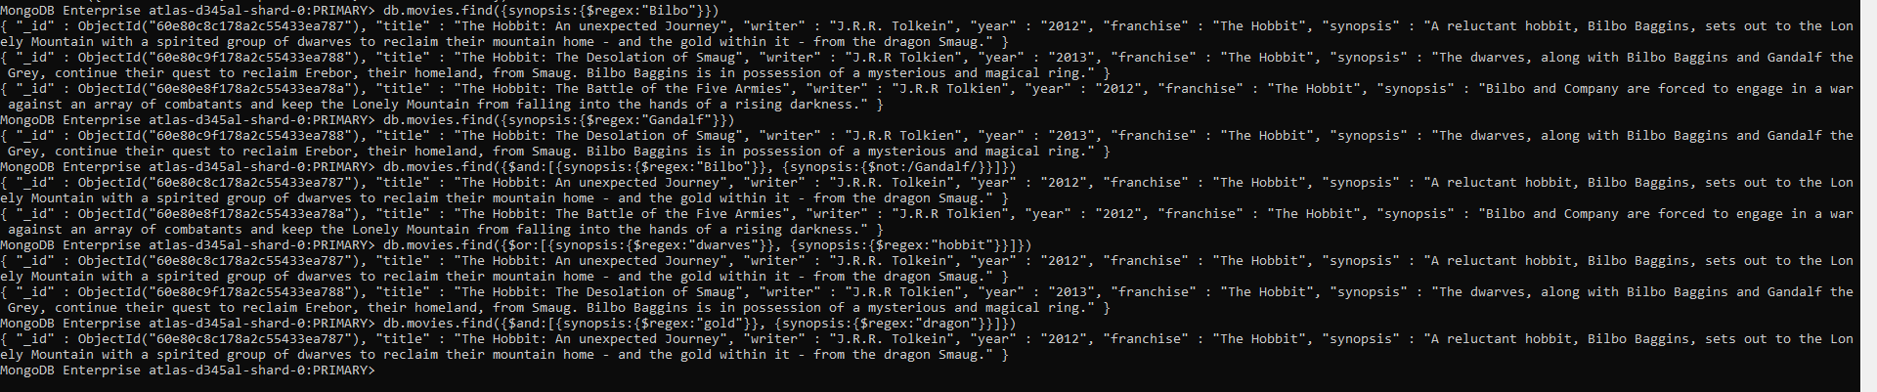

MongoDB Enterprise atlas-d345al-shard-0:PRIMARY> db.movies.find({synopsis:{$regex:"Bilbo"}})

{ "_id" : ObjectId("60e80c8c178a2c55433ea787"), "title" : "The Hobbit: An unexpected Journey", "writer" : "J.R.R. Tolkein", "year" : "2012", "franchise" : "The Hobbit", "synopsis" : "A reluctant hobbit, Bilbo Baggins, sets out to the Lonely Mountain with a spirited group of dwarves to reclaim their mountain home - and the gold within it - from the dragon Smaug." }

{ "_id" : ObjectId("60e80c9f178a2c55433ea788"), "title" : "The Hobbit: The Desolation of Smaug", "writer" : "J.R.R Tolkien", "year" : "2013", "franchise" : "The Hobbit", "synopsis" : "The dwarves, along with Bilbo Baggins and Gandalf the Grey, continue their quest to reclaim Erebor, their homeland, from Smaug. Bilbo Baggins is in possession of a mysterious and magical ring." }

{ "_id" : ObjectId("60e80e8f178a2c55433ea78a"), "title" : "The Hobbit: The Battle of the Five Armies", "writer" : "J.R.R Tolkien", "year" : "2012", "franchise" : "The Hobbit", "synopsis" : "Bilbo and Company are forced to engage in a war against an array of combatants and keep the Lonely Mountain from falling into the hands of a rising darkness." }

MongoDB Enterprise atlas-d345al-shard-0:PRIMARY> db.movies.find({synopsis:{$regex:"Gandalf"}})

{ "_id" : ObjectId("60e80c9f178a2c55433ea788"), "title" : "The Hobbit: The Desolation of Smaug", "writer" : "J.R.R Tolkien", "year" : "2013", "franchise" : "The Hobbit", "synopsis" : "The dwarves, along with Bilbo Baggins and Gandalf the Grey, continue their quest to reclaim Erebor, their homeland, from Smaug. Bilbo Baggins is in possession of a mysterious and magical ring." }

MongoDB Enterprise atlas-d345al-shard-0:PRIMARY> db.movies.find({$and:[{synopsis:{$regex:"Bilbo"}}, {synopsis:{$not:/Gandalf/}}]})

{ "_id" : ObjectId("60e80c8c178a2c55433ea787"), "title" : "The Hobbit: An unexpected Journey", "writer" : "J.R.R. Tolkein", "year" : "2012", "franchise" : "The Hobbit", "synopsis" : "A reluctant hobbit, Bilbo Baggins, sets out to the Lonely Mountain with a spirited group of dwarves to reclaim their mountain home - and the gold within it - from the dragon Smaug." }

{ "_id" : ObjectId("60e80e8f178a2c55433ea78a"), "title" : "The Hobbit: The Battle of the Five Armies", "writer" : "J.R.R Tolkien", "year" : "2012", "franchise" : "The Hobbit", "synopsis" : "Bilbo and Company are forced to engage in a war against an array of combatants and keep the Lonely Mountain from falling into the hands of a rising darkness." }

MongoDB Enterprise atlas-d345al-shard-0:PRIMARY> db.movies.find({$or:[{synopsis:{$regex:"dwarves"}}, {synopsis:{$regex:"hobbit"}}]})

{ "_id" : ObjectId("60e80c8c178a2c55433ea787"), "title" : "The Hobbit: An unexpected Journey", "writer" : "J.R.R. Tolkein", "year" : "2012", "franchise" : "The Hobbit", "synopsis" : "A reluctant hobbit, Bilbo Baggins, sets out to the Lonely Mountain with a spirited group of dwarves to reclaim their mountain home - and the gold within it - from the dragon Smaug." }

{ "_id" : ObjectId("60e80c9f178a2c55433ea788"), "title" : "The Hobbit: The Desolation of Smaug", "writer" : "J.R.R Tolkien", "year" : "2013", "franchise" : "The Hobbit", "synopsis" : "The dwarves, along with Bilbo Baggins and Gandalf the Grey, continue their quest to reclaim Erebor, their homeland, from Smaug. Bilbo Baggins is in possession of a mysterious and magical ring." }

MongoDB Enterprise atlas-d345al-shard-0:PRIMARY> db.movies.find({$and:[{synopsis:{$regex:"gold"}}, {synopsis:{$regex:"dragon"}}]})

{ "_id" : ObjectId("60e80c8c178a2c55433ea787"), "title" : "The Hobbit: An unexpected Journey", "writer" : "J.R.R. Tolkein", "year" : "2012", "franchise" : "The Hobbit", "synopsis" : "A reluctant hobbit, Bilbo Baggins, sets out to the Lonely Mountain with a spirited group of dwarves to reclaim their mountain home - and the gold within it - from the dragon Smaug." }

MongoDB Enterprise atlas-d345al-shard-0:PRIMARY>

**DELETE DOCUMENTS:**







MongoDB Enterprise atlas-d345al-shard-0:PRIMARY> db.movies.remove({_id:ObjectId("60e80eba178a2c55433ea78b")})

WriteResult({ "nRemoved" : 1 })

MongoDB Enterprise atlas-d345al-shard-0:PRIMARY> db.movies.remove({_id:ObjectId("60e80ec3178a2c55433ea78c")})

WriteResult({ "nRemoved" : 1 })

MongoDB Enterprise atlas-d345al-shard-0:PRIMARY>

**OUTPUT:**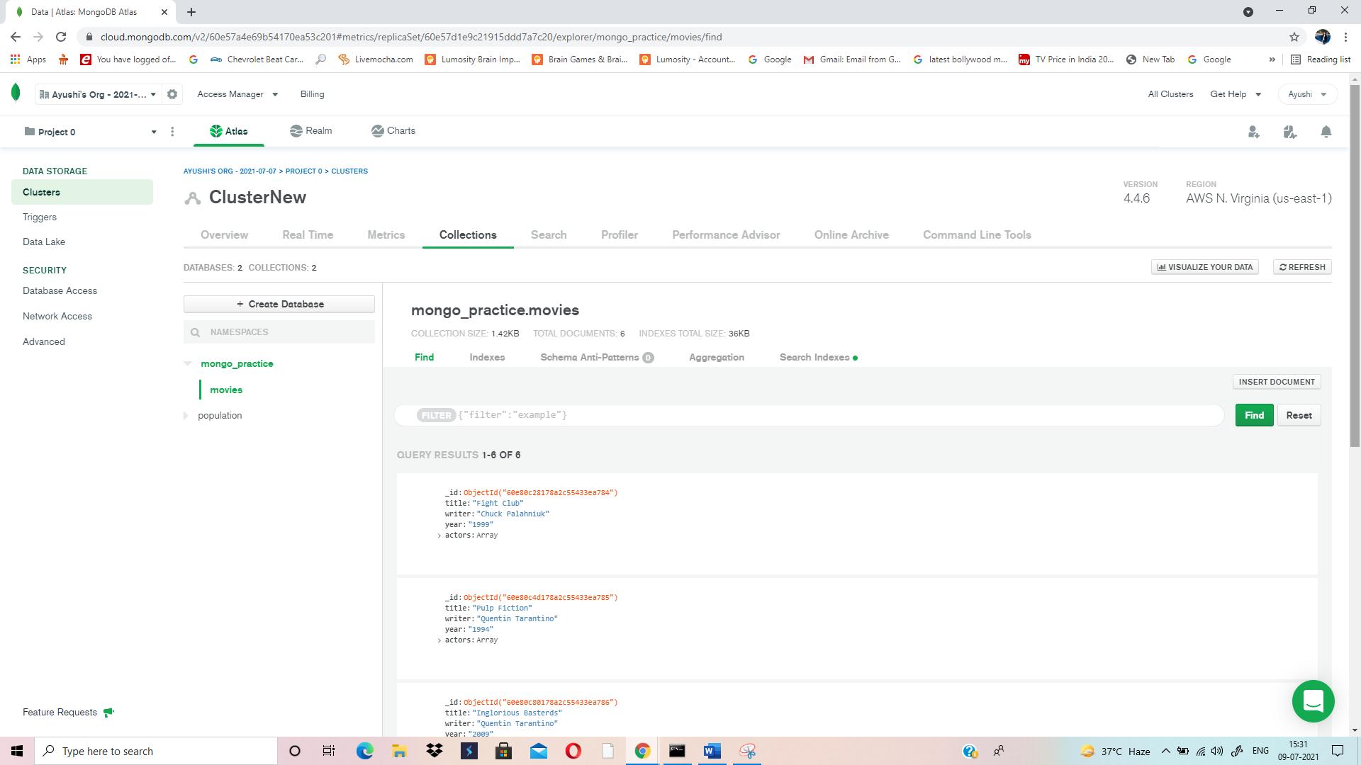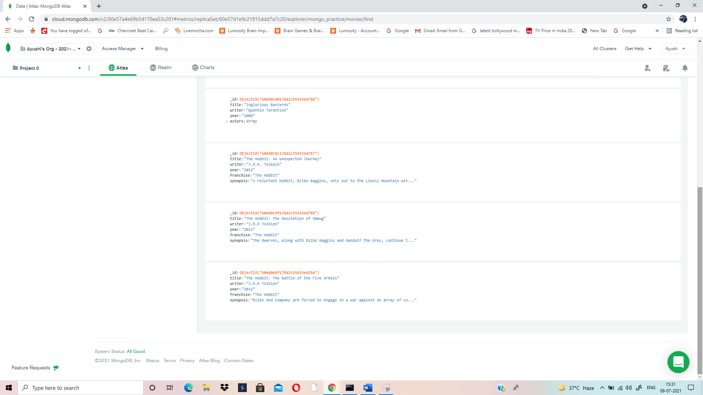

**RELATIONSHIPS:**

**INSERT THE FOLLOWING DOCUMENT INTO A USERS COLLECTION:**

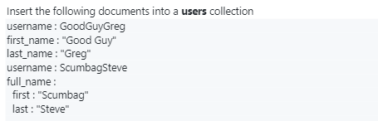



MongoDB Enterprise atlas-d345al-shard-0:PRIMARY> db.users.insert({_id:1,username:"GoodGuyGreg", first_name:"Good Guy", last_name:"Greg"})

WriteResult({ "nInserted" : 1 })

MongoDB Enterprise atlas-d345al-shard-0:PRIMARY> db.users.insert({_id:2, username:"ScumbagSteve", fullname:{first: "Scumbag", last:"Steve"}})

WriteResult({ "nInserted" : 1 })

**OUTPUT:**

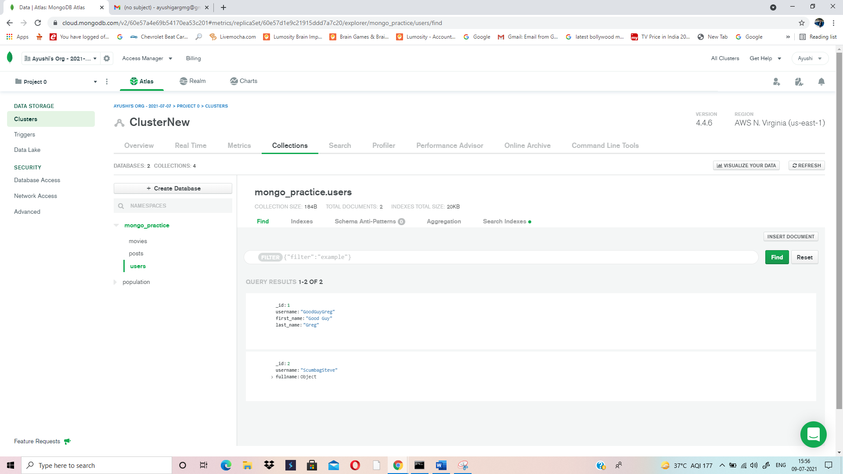

**INSERT THE FOLLOWING DOCUMENT INTO A COLLECTION:**

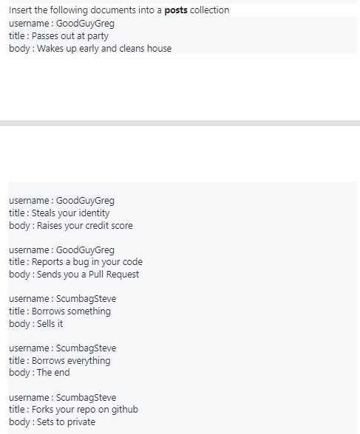

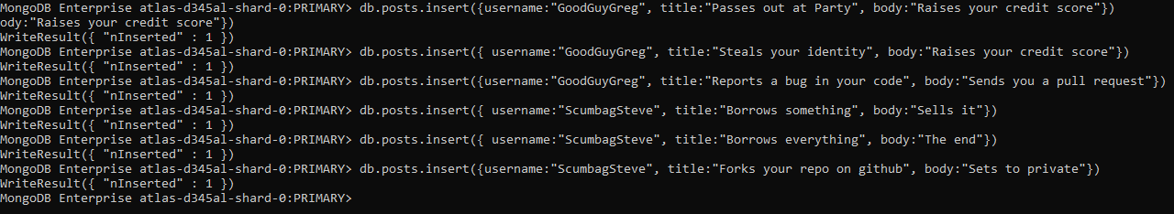

MongoDB Enterprise atlas-d345al-shard-0:PRIMARY> db.posts.insert({username:"GoodGuyGreg", title:"Passes out at Party", body:"Raises your credit score"})

WriteResult({ "nInserted" : 1 })

MongoDB Enterprise atlas-d345al-shard-0:PRIMARY> db.posts.insert({ username:"GoodGuyGreg", title:"Steals your identity", body:"Raises your credit score"})

WriteResult({ "nInserted" : 1 })

MongoDB Enterprise atlas-d345al-shard-0:PRIMARY> db.posts.insert({username:"GoodGuyGreg", title:"Reports a bug in your code", body:"Sends you a pull request"})

WriteResult({ "nInserted" : 1 })

MongoDB Enterprise atlas-d345al-shard-0:PRIMARY> db.posts.insert({ username:"ScumbagSteve", title:"Borrows something", body:"Sells it"})

WriteResult({ "nInserted" : 1 })

MongoDB Enterprise atlas-d345al-shard-0:PRIMARY> db.posts.insert({ username:"ScumbagSteve", title:"Borrows everything", body:"The end"})

WriteResult({ "nInserted" : 1 })

MongoDB Enterprise atlas-d345al-shard-0:PRIMARY> db.posts.insert({username:"ScumbagSteve", title:"Forks your repo on github", body:"Sets to private"})

WriteResult({ "nInserted" : 1 })

MongoDB Enterprise atlas-d345al-shard-0:PRIMARY>

**OUTPUT:**

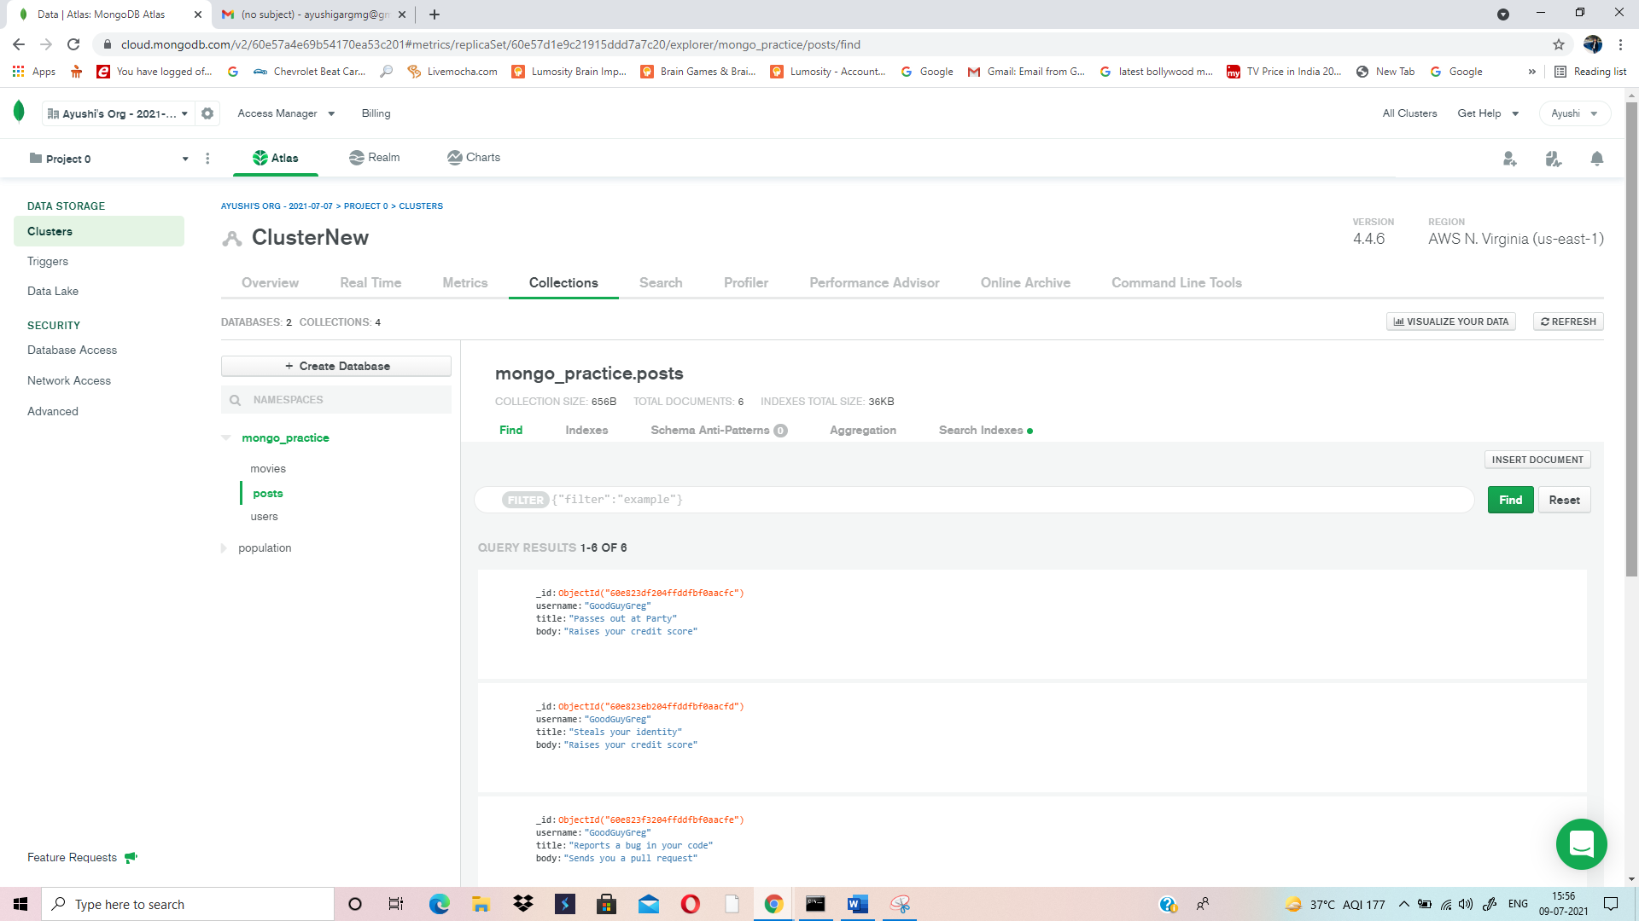

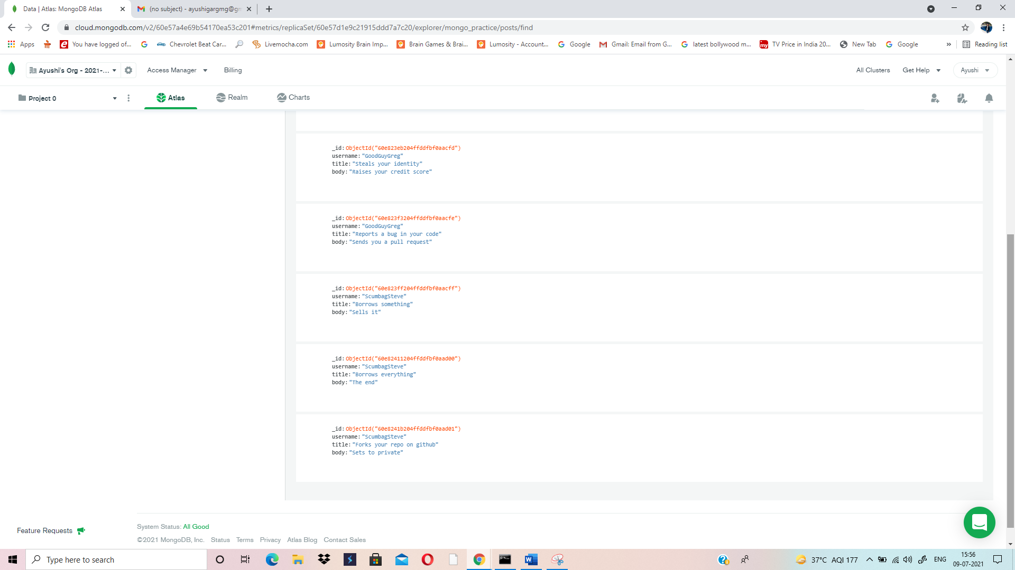

**INSERT THE FOLLOWING DOCUMENT INTO A COLLECTION:**

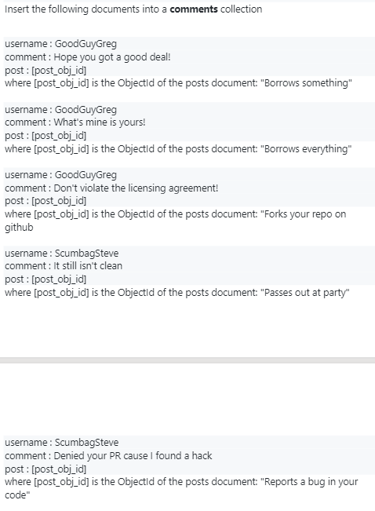

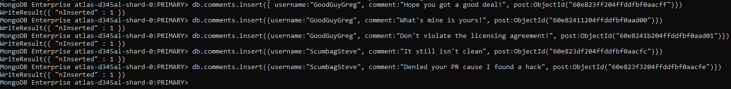

MongoDB Enterprise atlas-d345al-shard-0:PRIMARY> db.comments.insert({ username:"GoodGuyGreg", comment:"Hope you got a good deal!", post:ObjectId("60e823ff204ffddfbf0aacff")})

WriteResult({ "nInserted" : 1 })

MongoDB Enterprise atlas-d345al-shard-0:PRIMARY> db.comments.insert({username:"GoodGuyGreg", comment:"What's mine is yours!", post:ObjectId("60e82411204ffddfbf0aad00")})

WriteResult({ "nInserted" : 1 })

MongoDB Enterprise atlas-d345al-shard-0:PRIMARY> db.comments.insert({username:"GoodGuyGreg", comment:"Don't violate the licensing agreement!", post:ObjectId("60e8241b204ffddfbf0aad01")})

WriteResult({ "nInserted" : 1 })

MongoDB Enterprise atlas-d345al-shard-0:PRIMARY> db.comments.insert({username:"ScumbagSteve", comment:"It still isn't clean", post:ObjectId("60e823df204ffddfbf0aacfc")})

WriteResult({ "nInserted" : 1 })

MongoDB Enterprise atlas-d345al-shard-0:PRIMARY> db.comments.insert({username:"ScumbagSteve", comment:"Denied your PR cause I found a hack", post:ObjectId("60e823f3204ffddfbf0aacfe")})

WriteResult({ "nInserted" : 1 })

MongoDB Enterprise atlas-d345al-shard-0:PRIMARY>

**OUTPUT:**

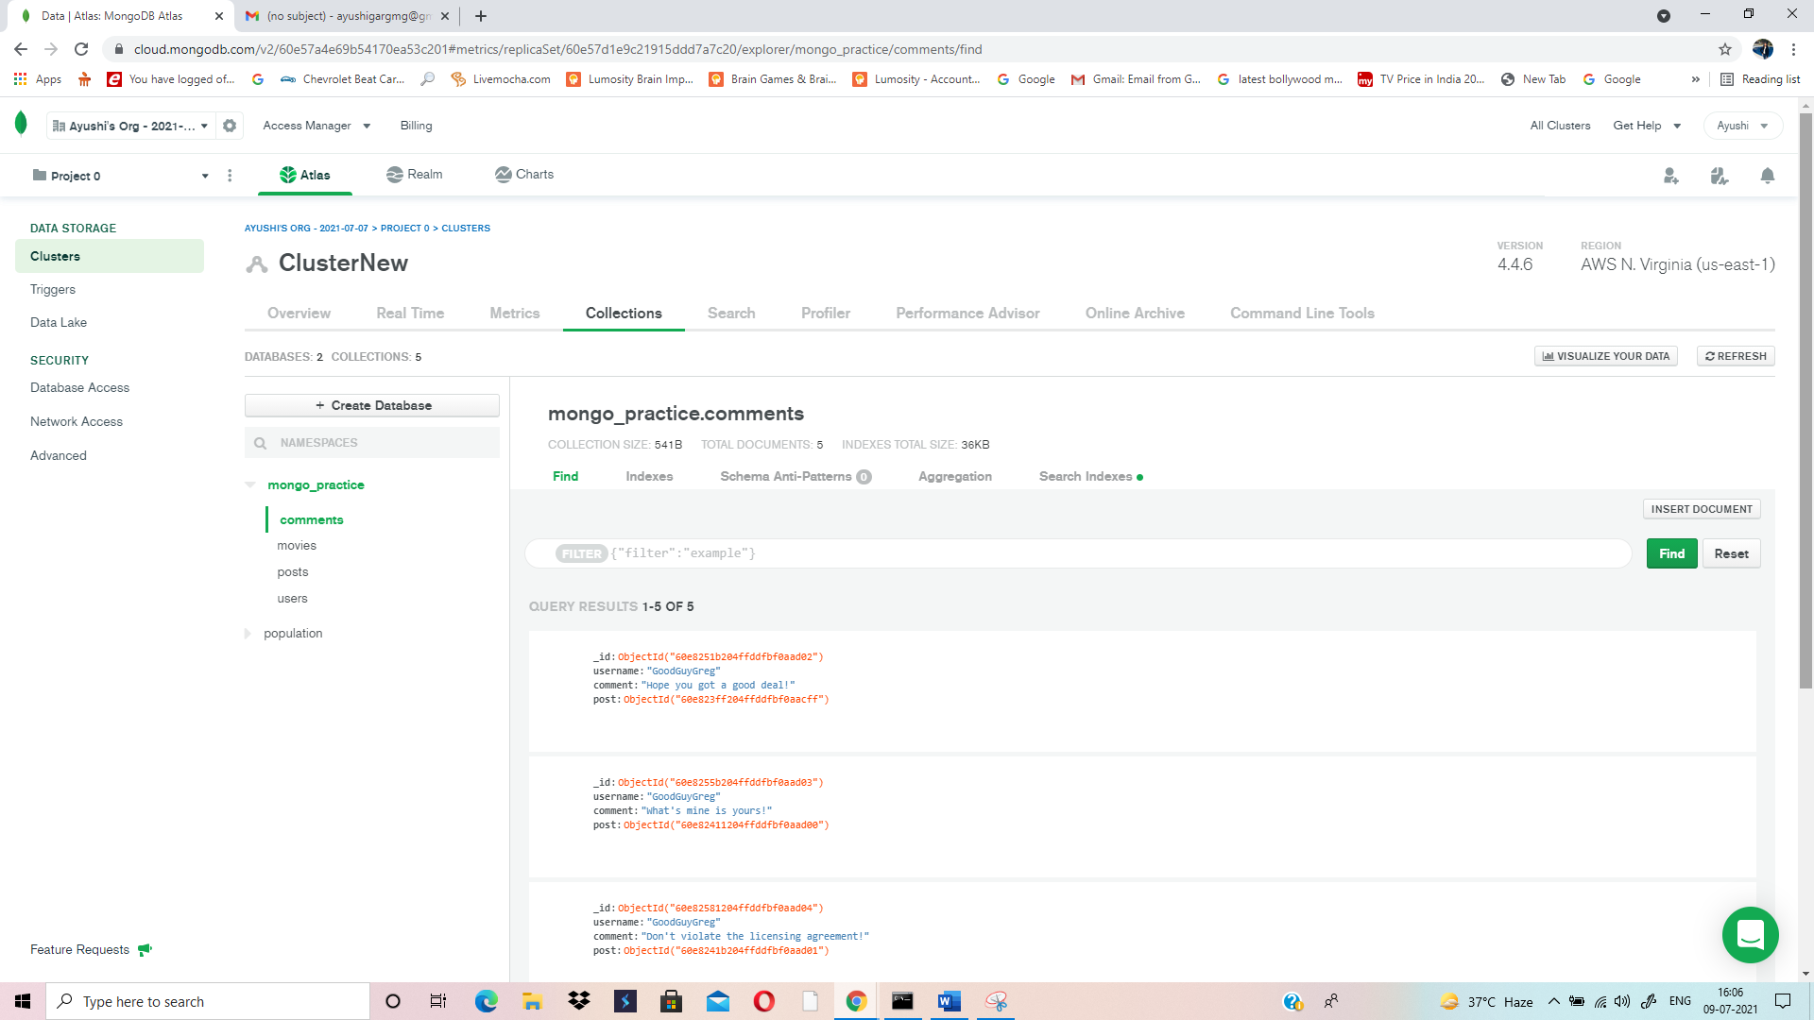

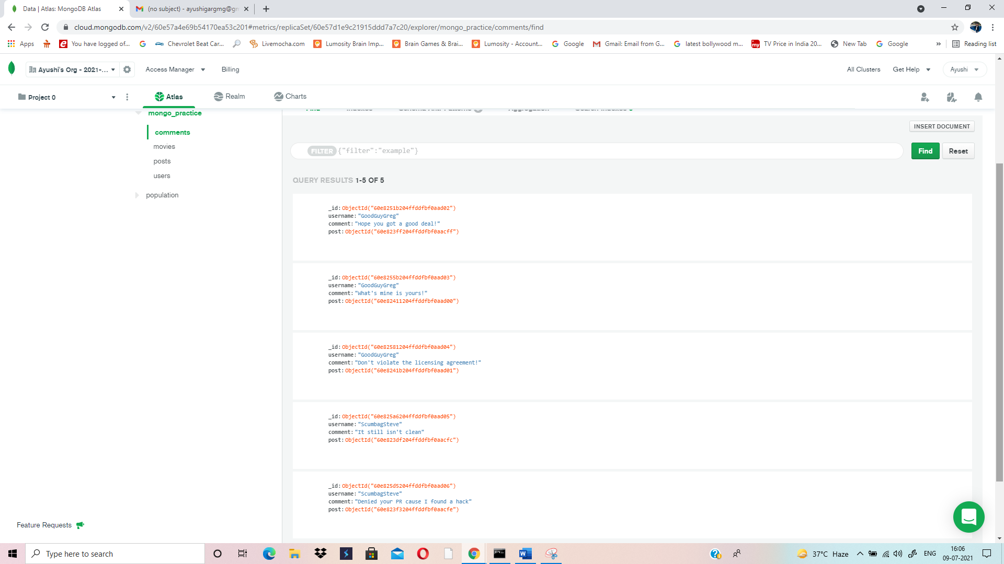

**QUERYING RELATED COLLECTION:**

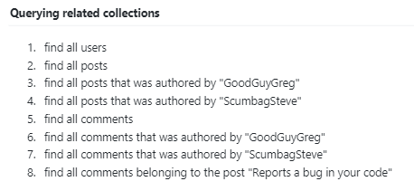

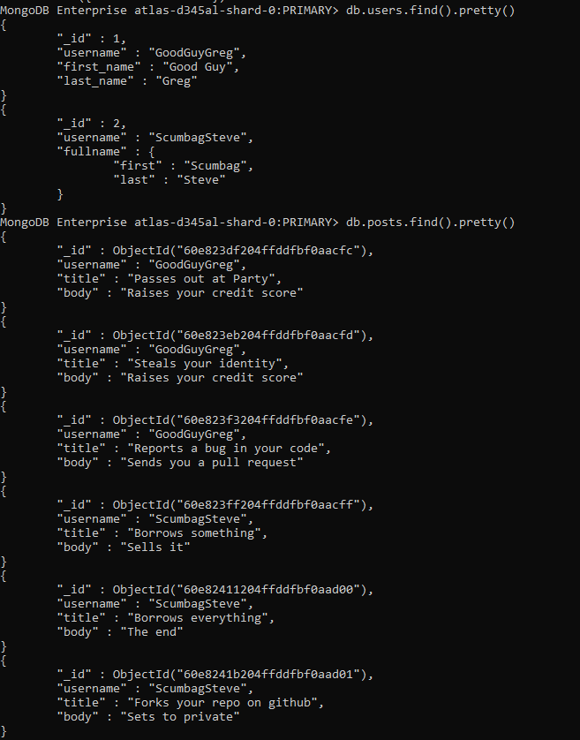

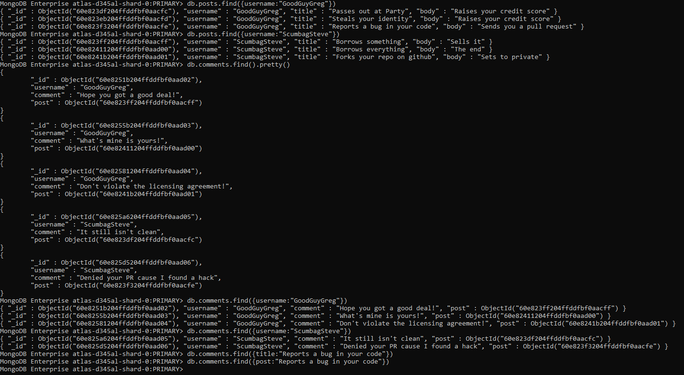

MongoDB Enterprise atlas-d345al-shard-0:PRIMARY> db.users.find().pretty()

{

"_id" : 1,

"username" : "GoodGuyGreg",

"first_name" : "Good Guy",

"last_name" : "Greg"

}

{

"_id" : 2,

"username" : "ScumbagSteve",

"fullname" : {

"first" : "Scumbag",

"last" : "Steve"

}

}

MongoDB Enterprise atlas-d345al-shard-0:PRIMARY> db.posts.find().pretty()

{

"_id" : ObjectId("60e823df204ffddfbf0aacfc"),

"username" : "GoodGuyGreg",

"title" : "Passes out at Party",

"body" : "Raises your credit score"

}

{

"_id" : ObjectId("60e823eb204ffddfbf0aacfd"),

"username" : "GoodGuyGreg",

"title" : "Steals your identity",

"body" : "Raises your credit score"

}

{

"_id" : ObjectId("60e823f3204ffddfbf0aacfe"),

"username" : "GoodGuyGreg",

"title" : "Reports a bug in your code",

"body" : "Sends you a pull request"

}

{

"_id" : ObjectId("60e823ff204ffddfbf0aacff"),

"username" : "ScumbagSteve",

"title" : "Borrows something",

"body" : "Sells it"

}

{

"_id" : ObjectId("60e82411204ffddfbf0aad00"),

"username" : "ScumbagSteve",

"title" : "Borrows everything",

"body" : "The end"

}

{

"_id" : ObjectId("60e8241b204ffddfbf0aad01"),

"username" : "ScumbagSteve",

"title" : "Forks your repo on github",

"body" : "Sets to private"

}

MongoDB Enterprise atlas-d345al-shard-0:PRIMARY> db.posts.find({username:"GoodGuyGreg"})

{ "_id" : ObjectId("60e823df204ffddfbf0aacfc"), "username" : "GoodGuyGreg", "title" : "Passes out at Party", "body" : "Raises your credit score" }

{ "_id" : ObjectId("60e823eb204ffddfbf0aacfd"), "username" : "GoodGuyGreg", "title" : "Steals your identity", "body" : "Raises your credit score" }

{ "_id" : ObjectId("60e823f3204ffddfbf0aacfe"), "username" : "GoodGuyGreg", "title" : "Reports a bug in your code", "body" : "Sends you a pull request" }

MongoDB Enterprise atlas-d345al-shard-0:PRIMARY> db.posts.find({username:"ScumbagSteve"})

{ "_id" : ObjectId("60e823ff204ffddfbf0aacff"), "username" : "ScumbagSteve", "title" : "Borrows something", "body" : "Sells it" }

{ "_id" : ObjectId("60e82411204ffddfbf0aad00"), "username" : "ScumbagSteve", "title" : "Borrows everything", "body" : "The end" }

{ "_id" : ObjectId("60e8241b204ffddfbf0aad01"), "username" : "ScumbagSteve", "title" : "Forks your repo on github", "body" : "Sets to private" }

MongoDB Enterprise atlas-d345al-shard-0:PRIMARY> db.comments.find().pretty()

{

"_id" : ObjectId("60e8251b204ffddfbf0aad02"),

"username" : "GoodGuyGreg",

"comment" : "Hope you got a good deal!",

"post" : ObjectId("60e823ff204ffddfbf0aacff")

}

{

"_id" : ObjectId("60e8255b204ffddfbf0aad03"),

"username" : "GoodGuyGreg",

"comment" : "What's mine is yours!",

"post" : ObjectId("60e82411204ffddfbf0aad00")

}

{

"_id" : ObjectId("60e82581204ffddfbf0aad04"),

"username" : "GoodGuyGreg",

"comment" : "Don't violate the licensing agreement!",

"post" : ObjectId("60e8241b204ffddfbf0aad01")

}

{

"_id" : ObjectId("60e825a6204ffddfbf0aad05"),

"username" : "ScumbagSteve",

"comment" : "It still isn't clean",

"post" : ObjectId("60e823df204ffddfbf0aacfc")

}

{

"_id" : ObjectId("60e825d5204ffddfbf0aad06"),

"username" : "ScumbagSteve",

"comment" : "Denied your PR cause I found a hack",

"post" : ObjectId("60e823f3204ffddfbf0aacfe")

}

MongoDB Enterprise atlas-d345al-shard-0:PRIMARY> db.comments.find({username:"GoodGuyGreg"})

{ "_id" : ObjectId("60e8251b204ffddfbf0aad02"), "username" : "GoodGuyGreg", "comment" : "Hope you got a good deal!", "post" : ObjectId("60e823ff204ffddfbf0aacff") }

{ "_id" : ObjectId("60e8255b204ffddfbf0aad03"), "username" : "GoodGuyGreg", "comment" : "What's mine is yours!", "post" : ObjectId("60e82411204ffddfbf0aad00") }

{ "_id" : ObjectId("60e82581204ffddfbf0aad04"), "username" : "GoodGuyGreg", "comment" : "Don't violate the licensing agreement!", "post" : ObjectId("60e8241b204ffddfbf0aad01") }

MongoDB Enterprise atlas-d345al-shard-0:PRIMARY> db.comments.find({username:"ScumbagSteve"})

{ "_id" : ObjectId("60e825a6204ffddfbf0aad05"), "username" : "ScumbagSteve", "comment" : "It still isn't clean", "post" : ObjectId("60e823df204ffddfbf0aacfc") }

{ "_id" : ObjectId("60e825d5204ffddfbf0aad06"), "username" : "ScumbagSteve", "comment" : "Denied your PR cause I found a hack", "post" : ObjectId("60e823f3204ffddfbf0aacfe") }

MongoDB Enterprise atlas-d345al-shard-0:PRIMARY> db.comments.find({title:"Reports a bug in your code"})

MongoDB Enterprise atlas-d345al-shard-0:PRIMARY> db.comments.find({post:"Reports a bug in your code"})

MongoDB Enterprise atlas-d345al-shard-0:PRIMARY>